Assignment 3 - Fundamentals of Data Science

Student Name: Jatan Timilsina

Module: Fundamentals of Data Science

Assignment: Week 5 & 6 Programming Tasks

# 1. Read CSV File

This program reads a 'students.csv' file and prints its contents, including name, id, course, level, and section.

Output:

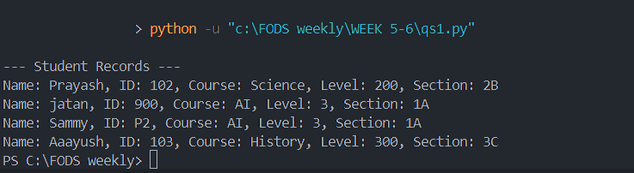

# 2. Append to CSV File

This program collects user details (name, id, course, level, section) and appends them to the 'students.csv' file.

Output:

# 3. Arithmetic on List and Write to File

This program accepts a list of numbers, performs arithmetic operations, writes the results with timestamp to a file, and supports repeated execution until the user exits.

Output:

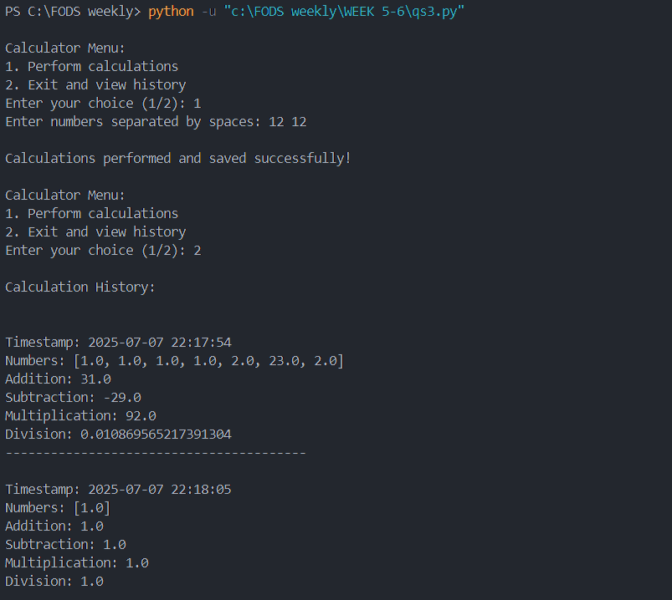

# 4. Copy File with Exception Handling

This program reads content from one file and writes it to another. It includes exception handling for missing input files and existing output files.

Output:

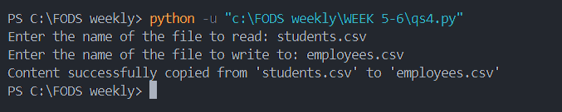

# 5. Student Class

This program defines a Student class with various attributes, takes user input to fill them, and displays the data.

Output:

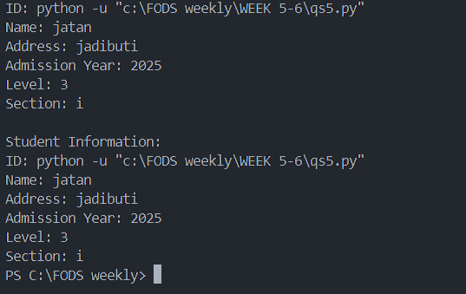

# 6. Recipe and Recipe Book Classes

This program defines a Recipe class and a RecipeBook class to manage multiple recipes, with attributes like id, name, ingredients, and description.

Output:

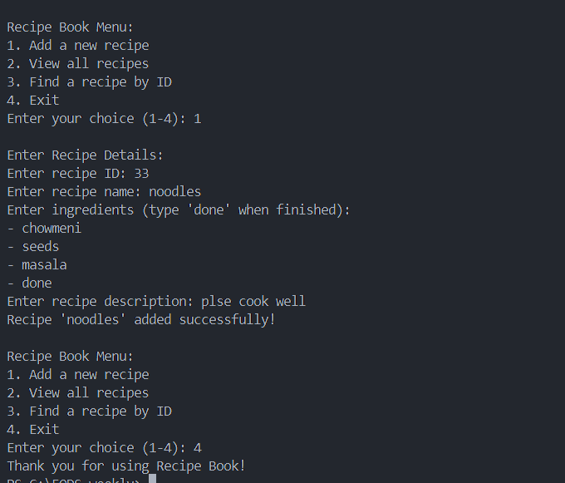

# 7. Employee Class with File Handling

This program creates an Employee class, collects and stores employee details in 'employees.csv', and displays them. It also uses exception handling.

Output:

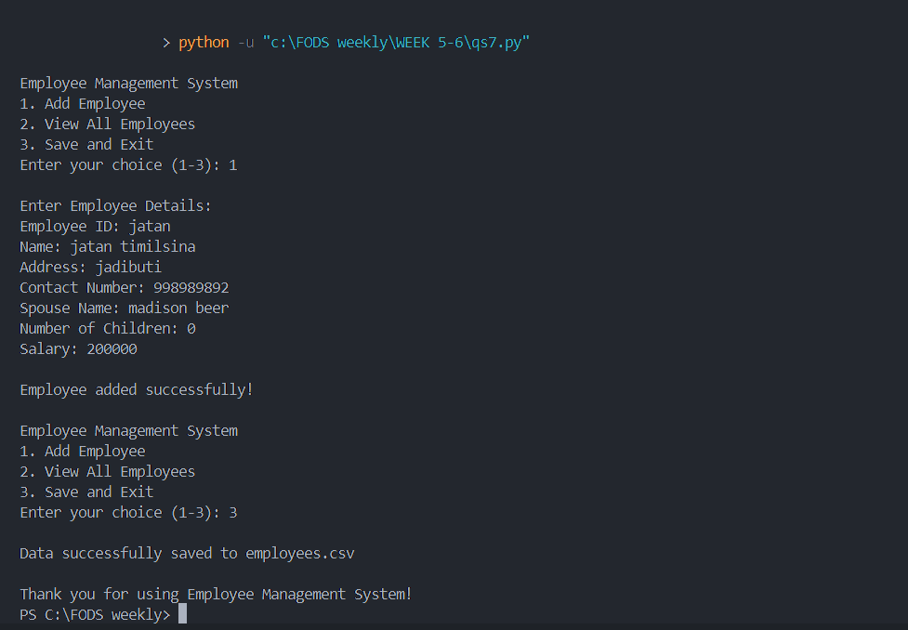

# 8. Library Book Management System

This program implements a basic library system using OOP with features like issue, return, and search. It includes file and exception handling.

Output:

